Philhealth ID Simulation - Mother Ignacia, QC.
Branch

John Edward Complido
BSCS3AB
Department of Science
Technological University of the Philippines - Manila
johnedward.complido@tup.edu.ph
Saeymond Charles Serrano
BSCS3AB
Department of Science
Technological University of the Philippines - Manila
saeymondcharles.serrano@tup.edu.ph
Fran Kyle Ledesma
BSCS3AB
Department of Science
Technological University of the Philippines - Manila
frankyle.ledesma@tup.edu.ph
Patrick Yee
BSCS3AB
Department of Science
Technological University of the Philippines - Manila
patrick.yee@tup.edu.ph

Abstract— Having a PhilHealth ID will give an individual proof of membership in the PhilHealth organization. The PhilHealth ID Card is recognized as a valid ID in the Philippines and is useful in doing basic transactions to identify a person as a citizen of the country. A discrete event simulation model was used to evaluate the process of getting a PhilHealth Id. Using T-test to check the significance of the real-life data and the simulation data which showed an almost significant result that was accepted.

Introduction
Very little is known about the Philippine health care system, and particularly its experience with social health insurance (SHI). PhilHealth was formed in 1995 as a successor to the Medicare programme and was given a mandate to achieve universal coverage by 2010 ^{[3]}. In strengthening eHealth in the Philippines to support the universal health care (UHC) law, the scaling up and full adoption of electronic medical record (EMR) systems was strategically scheduled and supposedly completed in 2020 ^{[1]}. An electronic identification system is a crucial component for every civilized nation and has been proven to be a successful way to improve public services in modern government systems.
Having a PhilHealth ID will give an individual proof of membership in the PhilHealth organization. The PhilHealth ID Card is recognized as a valid ID in the Philippines and is useful in doing basic transactions to identify a person as a citizen of the country. Indigent membership in PhilHealth has surged in recent years, driven by the nation-wide identification of the poor. However, massive identification has led to the enrollment of more members than official poverty estimates, resulting in leakages in the government’s social health insurance subsidy ^{[2]}. PhilHealth ID also has other uses aside from insurance, as it is being used to verify identity when conducting a transaction online. The PhilHealth ID is a paper ID issued upon registration without corresponding fees, not like other valid ID’s that can be costly. Therefore, many Filipino youths apply for the membership of PhilHealth organization to get an ID card for the purpose of verifying online accounts, but the uses of the PhilHealth ID can be limited as some other companies or sectors do not accept it.

Modeling approach
A discrete event simulation model was developed to evaluate the process in getting a PhilHealth ID. The simulation model was initially validated using the data from PhilHealth – mother Ignacia branch in Quezon City.

Input analysis
Getting a PhilHealth ID is not time homogenous as it is related to the number of employments in the Philippines. We focused in the area of Mother Ignacia branch in Quezon City. It is the largest City in the Philippines with a population that is almost 3 million. The age range of eligible people that can get an Id is between 21 years old and above, there are some exceptions in this as there are many below 21 years old and cannot be lower than 18, that are already working in companies, and being a member of PhilHealth is a must. The acceptance rate in getting an Id is 90% as there are only limited factors that could affect in the eligibility in getting an Id. The 10% are people who are not eligible because they do not meet the age limit or they did not bring the required documents for the application of the Id.

Project Objectives
The purpose of this project’s simulation was to make the process of getting a PhilHealth ID smoother by considering the factors below:
- Client – Decreasing the Queue/Waiting time of the client while they are in the process of application and getting the actual ID.
- Staff – Not implicating the workload of the staff members by decreasing the queue/waiting time of the clients.
- Facility – Assessing the capacity of the facility by having the changes stated.

DES model for Philhealth Id
In this section, we present the DES simulation model developed for the process of getting a PhilHealth Id and the approach used for validation.
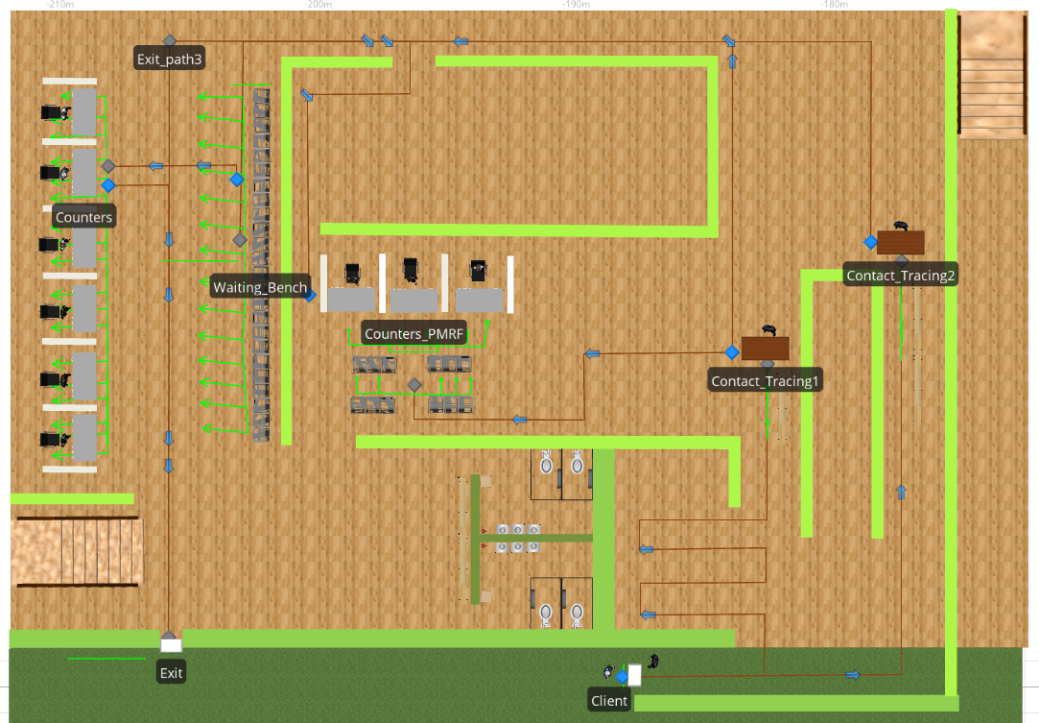
Figure 1. DES model for the PhilHealth facility

DES Simulation Model
Figure 1 shows a snapshot of a part of the DES model developed for the PhilHealth facility using Simio simulation software. Simio allows flexible modeling that promotes a clean and flexible model structure that enhances understanding by the non-model developers. The information required for running the simulation model was saved within the file of Simio. The input required for the running the simulation model can be classified in the following categories:
1. Simulation parameters: Simulation run length, number of servers.
2. Production information: Processing schedule, server batch times, server capacity and other system flow rates.
3. Failure information: The entities inside while the program was stopped because of the end time schedule.
The simulation model runs on a daily basis with a 9 hours duration. For this problem, it was assumed that the flow of entities was randomized, even the queue time of each server was only closely accurate. The failure information was not included as they did not complete the process.

Approach
To improve the productivity of the facility the group proposed an enhanced version of the process flow.
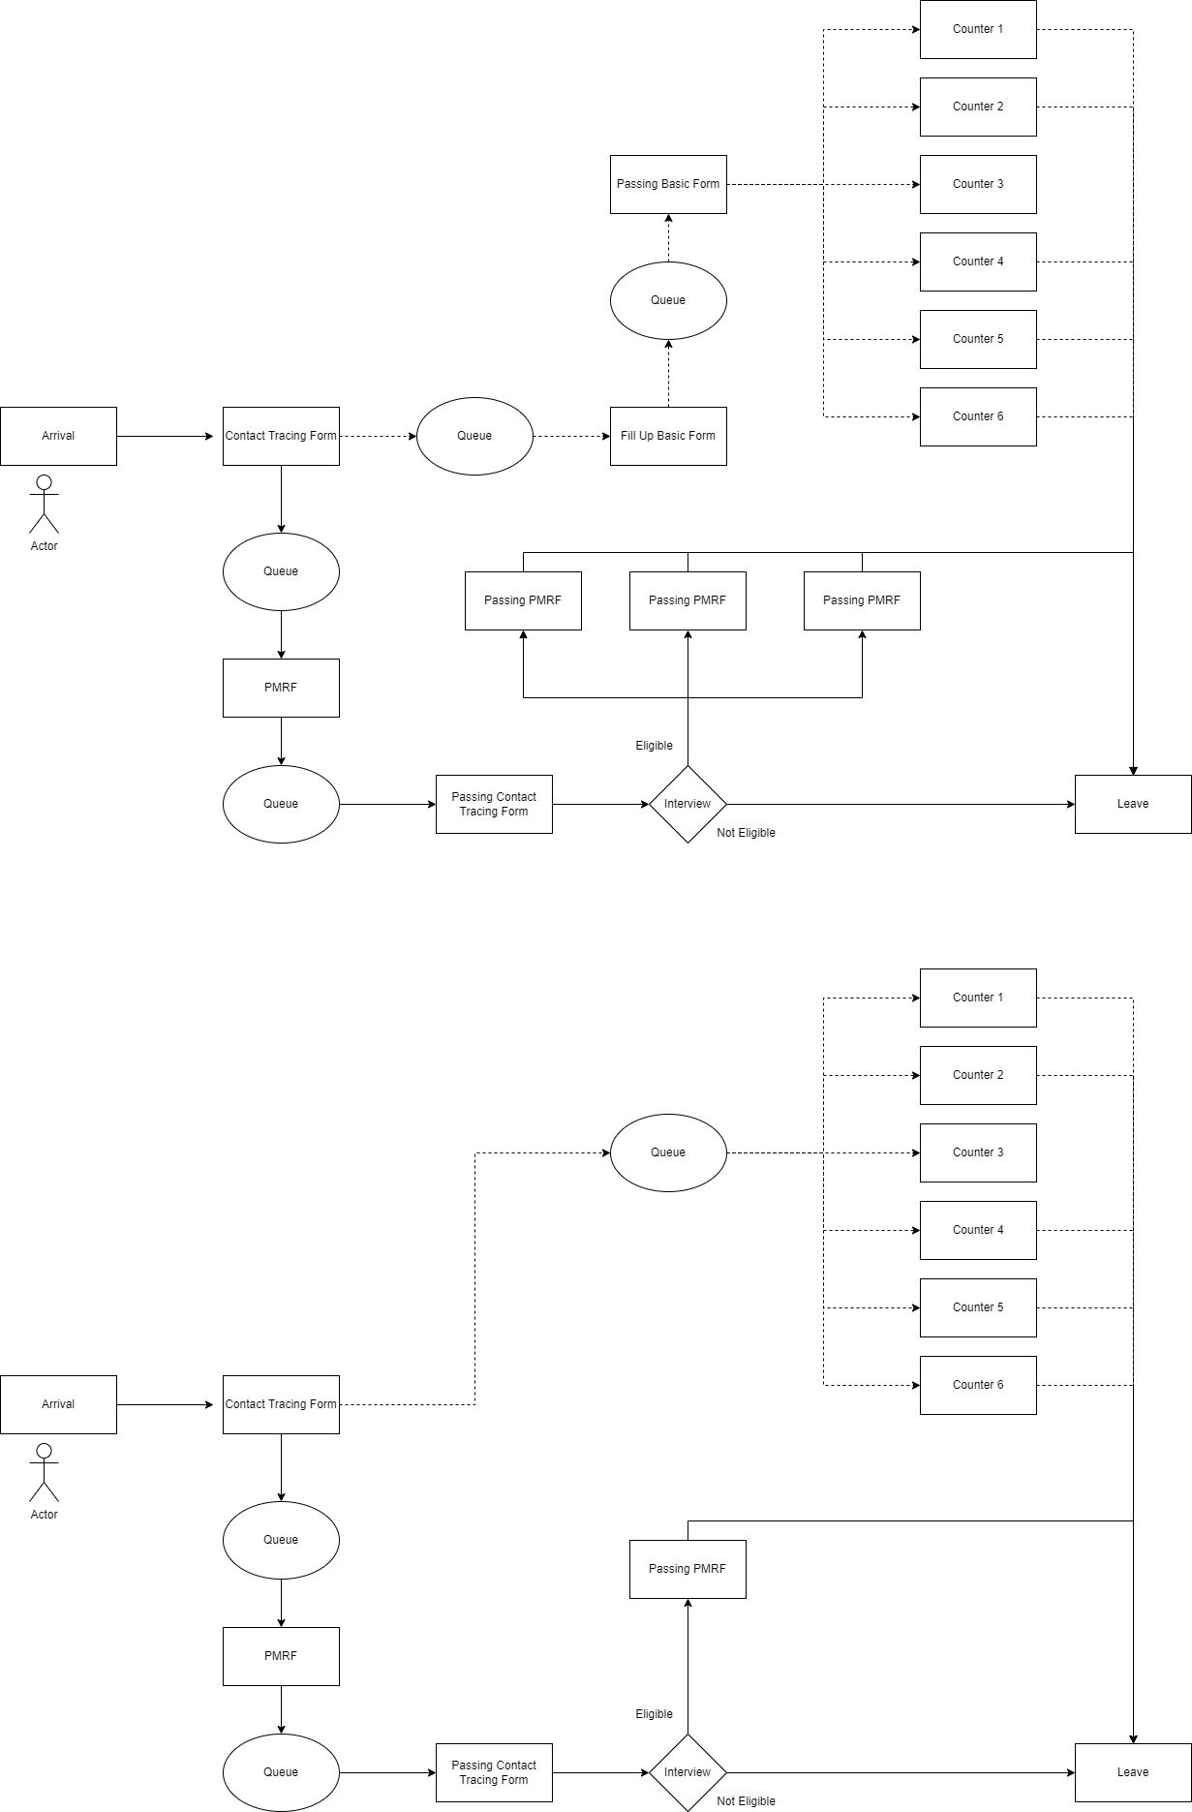
Figure 2. Original Model

Figure 2 shows the original model of the facility in which we used as a base to create a proposed model that enhanced the process flow of the entire facility.
Figure 3. Proposed Model

Figure 3 shows the proposed model for the facility in which there are additional servers than the original one.

Validation
The equation used to validate the model was two tails paired t-test by using the data from PhilHealth for the whole month of June, 2022.
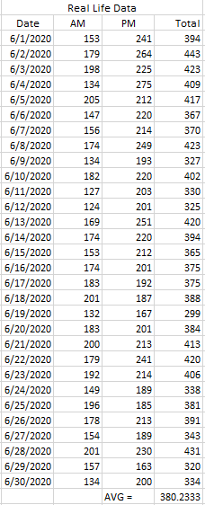

Table 1. Real-life Data

Table 1 shows the real-life data from PhilHealth facility. The data was separated into two parts, which is the AM and the PM. Using Microsoft Excel to get the total population per day and then the average for the whole month.
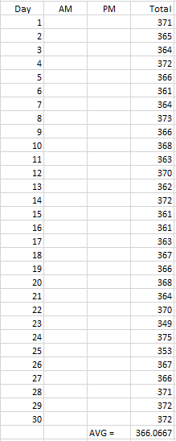

Table 2. Simulation Data
Table 2 shows the simulation data we got from Simio, by changing the randomness of the in running the simulation we managed to gather the data worth of a month, but we did not manage to segregate the data into AM and PM as the result from the simulation was summarized.
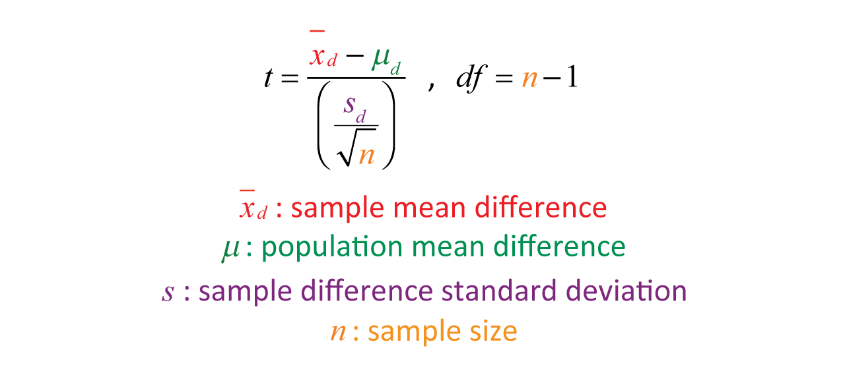

Using the 2-tails paired t-test we manage to validate our data by getting the significance level of the Simulation level to the Original Model.

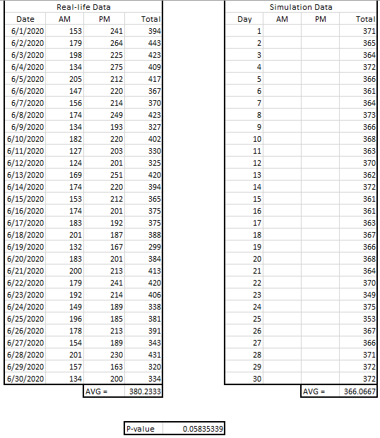
Figure 4. Data Results from Excel

In Figure 4 show the summary of the data result which was screenshot from excel. The excel was used to input and compute the data. The validation resulted in almost significant from the simulation data to the real-life data, which was accepted.

Conclusion
The simulation was almost significant to the real-life model, but the overall objectives was not met as the data from the simulation was behind the real-life data which means there was no improvement that happened to the process flow of the PhilHealth facility.
Adding a few servers can change the simulation data that could make an improvement to the process flow, the properties of the servers could also be changed by manipulating the initial capacity, processing time and time arrival that could improve the entities intake of the model.

References

- P. J. Acacio-Claro, M. R. Justina Estuar, D. A. Villamor, M. C. Bautista, Q. Sugon, and C. Pulmano, “A Micro-analysis Approach in Understanding Electronic Medical Record Usage in Rural Communities: Comparison of Frequency of Use on Performance Before and During the COVID-19 Pandemic,” Procedia Computer Science, vol. 196, pp. 572–580, Jan. 2022, doi: 10.1016/j.procs.2021.12.051.
- M. R. Cabalfin, “Health financing for the poor in the Philippines: Final report,” www.econstor.eu, 2016. https://www.econstor.eu/handle/10419/173558 (accessed Jun. 30, 2022).
- K. Obermann, M. R. Jowett, M. O. O. Alcantara, E. P. Banzon, and C. Bodart, “Social health insurance in a developing country: The case of the Philippines,” Social Science & Medicine, vol. 62, no. 12, pp. 3177–3185, Jun. 2006, doi: 10.1016/j.socscimed.2005.11.047.

